DS_LAB_06_TASKS
Sir Shafique Rehman
24k-0919
Muhammad Fazeel

Task 1: Implement and insert the values “BORROWROB” in the stack and identify if it’s a palindrome
or not. Use the push and pop functions to accomplish this (Note: Use Arrays to accomplish this)

#include <iostream>
using namespace std;

class Node {
public:
char data;
Node* next;
Node (int val) {
data = val;
next = NULL;
}
};

class Stack {
private:
Node* top;

public:
Stack() {
top = nullptr;
}
void push(char value) {
Node* newNode = new Node(value);
if(top == NULL) {
top = newNode;
return;
}
newNode->next = top;
top = newNode;
}
void pop() {
if (isEmpty()) {
cout << "Stack underflow! No element: \n";
return ;
}
Node* temp = top;
top = top->next;
temp->next = NULL;
delete temp;
temp = NULL;
}

bool isEmpty() {
return top == NULL;
}

char top_element() {
if (isEmpty()) {
cout << "Stack is empty\n";
return -1;
}
return top->data;
}
void display() {
if (isEmpty()) {
cout<<"Stack is empty\n";
return;
}
Node* temp = top;
cout << "Stack elements: ";
while (temp != nullptr) {
cout << temp->data << " ";
temp = temp->next;
}
cout << "\n";
}
};

int main() {
string data = "BORROWROB";
string result;
Stack s;
for (int i = 0; i < data.size(); i++)
{
s.push(data[i]);
}
int i = 0;
while (!s.isEmpty())
{
if (s.top_element() != data[i]) {
cout << data << " is not a Palindrome: ";
return 0;
}
s.pop();
i++;
}
cout << data << " is a Palindrome: ";

return 0;
}

Output:
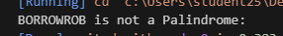

Task # 02:
Code:
#include<iostream>
#include <ctime>
using namespace std;

class Transaction {
private:
int id;
double amount;
string description;
bool isSale; // is money received
static int count;
public:
Transaction () {}

Transaction (double amount, string desc, bool isSale) {
this->amount = amount;
this->description = desc;
this->isSale = isSale;
count++;
id = count; // generating a unique ID
}

bool checkDescription () {
return description.size() > 20;
}

void cutDescription () {
if(checkDescription()) {
description = description.substr(0,20) + "...";
}
}
double getSaleAmount () { return amount; }

void setSaleAmountAfterDiscount (double amount) {
this->amount = amount;
}
void setTrasaction (double amount) {
this->amount = amount;
}

void setFlag (bool val) {
isSale = val;
}
string getDescription () { return description; }

void setDescription (string d) { this->description = d; }

void display () {
cout << "Transaction ID: " << id << "\n" << "Amount: " << amount << " PKR\n" << "Description: " << description << "\n"
<< "Type: " << (isSale ? "Sale" : "Refund") << "\n"
<< "-----------------------------\n";
}

};
int Transaction::count = 0;

class Node {
public:
Transaction transaction;
Node* next;

Node (Transaction val) {
transaction = val;
next = NULL;
}
};

class TransactionStore {
public:
Node *top;
TransactionStore () {
top = NULL;
}

void push (Transaction t) {
if (t.checkDescription()) { // check if description is greater than 20
t.cutDescription();
}

if (t.getSaleAmount() >= 0) {

float discount = 0;

if (t.getSaleAmount() >= 1500) discount = 0.30;
else if (t.getSaleAmount() >= 1000) discount = 0.15;
else if (t.getSaleAmount() >= 500) discount = 0.05;

if (discount > 0) {
cout<<discount * 100 << " percent discount applied on "<< t.getDescription() << endl;
}

double amount = t.getSaleAmount() - (t.getSaleAmount() * discount);
t.setSaleAmountAfterDiscount(amount);
}

Node *newtransaction = new Node (t);

if (top == NULL) {
top = newtransaction;
}
else {
newtransaction->next = top;
top = newtransaction;
}

cout << "\nTransaction added successfully:\n";
t.display();
}

void pop () {

if (top == NULL) {
cout << "Stack UnderFlow!\n";
return;
}

cout << "Reversing transaction...\n";
top->transaction.setTrasaction (top->transaction.getSaleAmount() * (-1)); // reversed
top->transaction.setFlag (false);

string description = top->transaction.getDescription() + " [REVERSED]";
top->transaction.setDescription (description);

top->transaction.display();

Node *temp = top;
top = top->next;
delete temp;
}

~TransactionStore () {
while (top != NULL) {
Node *temp = top;
top = top->next;
delete temp;
}
}
};

// this function is for checking which operator has high precedence:
int checkPrecedence(char op) {
if (op == '+' || op == '-') {
return 1;
}
else if (op == '*' || op == '/') {
return 2;
}
return 0;
}
// check wheather it is a operator:
bool isOperator(char c) {
if (c == '+' || c == '*'|| c == '-' || c == '/') {
return true;
}
return false;
}
string infixToPostfix(string infix) {
char arr[50]; // taking 50 size
int top = -1;
string postfix="";

for (int i = 0; i < infix.length(); i++) {
char ch = infix[i];

if ((ch >= '0' && ch <= '9') || ch == '.') {
postfix += ch;
}
else if (ch == '(') {
arr[++top] = ch;
}
else if (ch == ')') {
postfix += ' ';
while (top >= 0 && arr[top] != '(') {
postfix+=arr[top--];
postfix+=' ';
}
top--;
}
else if (isOperator(ch)) {
postfix+=' ';
while (top >= 0 && checkPrecedence(arr[top]) >= checkPrecedence(ch)) {
postfix+=arr[top--];
postfix+=' ';
}
arr[++top] = ch;
}
}
while (top >= 0) {
postfix += ' ';
postfix += arr[top--];
}
return postfix;
}

double evaluatePostfix(string postfix) {
double arr[50];
int top = -1;
string num = "";

for (int i = 0; i < postfix.length(); i++) {
char ch = postfix[i];
if (ch == ' ') {
if (num != "") {
arr[++top] = stod(num);
num = "";
}
}
else if (isOperator(ch)) {
double b = arr[top--];
double a = arr[top--];
double result = 0;

if (ch == '+') {
result = a + b;
}
else if (ch == '-') {
result = a - b;
}
else if (ch == '*') {
result = a * b;
}
else if (ch == '/') {
result = a / b;
}

arr[++top] = result;
}
else
{
num += ch;
}
}
return arr[top];
}

int main()
{
srand(time(0));

Transaction transactions[7] = {
Transaction(1200, "Sale: Blue Jacket", true),
Transaction(450, "Sale: Cotton Socks", true),
Transaction(-300, "Refund: Defective Shirt", false),
Transaction(1700, "Sale: Leather Jacket", true),
Transaction(600, "Sale: White Sneakers", true),
Transaction(-500, "Refund: Damaged Bag", false),
Transaction(2200, "Sale: Premium Watch", true)
};

TransactionStore store;
bool used[7] = {false};

int count = 0;
while (count < 4) {
int idx = rand() % 7;
if (!used[idx]) {
used[idx] = true;
store.push(transactions[idx]);
count++;
}
}

cout << "\n\nReversing 2 transactions...\n";
store.pop();
store.pop();

string infix = "(100+20)*0.9-5";
cout << "Infix: " << infix << endl;

string postfix = infixToPostfix(infix);
cout << "Postfix: " << postfix << endl;

double result = evaluatePostfix(postfix);
cout << "Evaluated Result: " << result << endl;

return 0;
}

Output:
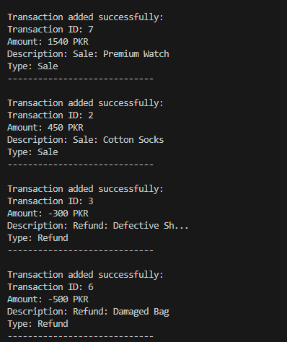
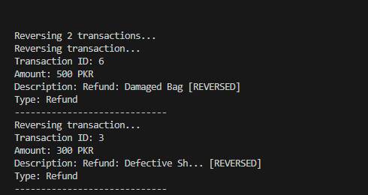
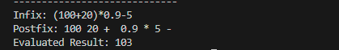

Task # 03:
1. Data Structure Choice:
Queue will be use because it works on the First In, First Out (FIFO) rule.
This means the first order received will also be the first to be get order, and that is requirement of restaurant system.
2. Adding Orders:
To add an order, use the enqueue operation, which store at rear of the queue.
And store each order (with item name and quantity) at the rear of the queue.
3. Removing Orders:
To process an order, use the dequeue operation, which will remove from front.
removes the order from the front, as it was the first one to come in (FIFO).
4. Preventing Overflow and Underflow:
Before adding, I will check if the queue is full to avoid overflow. Before removing, It will check if it is empty to avoid underflow.
Overflow will happen in case of arrays . We can also prevent it through linked list.
5. Displaying All Orders:
After processing, It will print all the orders from front to rear.
This ensures the staff sees them in the same order they were received and can serve customers correctly.

